1. The stained glass window design is a rhombus subdivided into four congruent rhombi. If the small angle at point M is 40° as shown, then what is angle DAB?

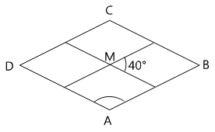

1. The square shown is divided into 4 congruent rectangles. Each of them has perimeter 30 cm. What is the perimeter of the square?

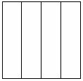

1. John is trying to make a rectangle on the given coordinate grid. He has already labeled the point A at (-1, -3), the point B at (1, -1), and point C at (-2, 2). Where should he plot point D to complete the rectangle?

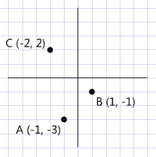

1. If the perimeter of a rectangle is 24 inches and the length of the rectangle is 3 inches, what is the width of the rectangle in inches?
2. A square is outlined in string and has an area of 64 square units. If you take the string to make a regular octagon that has the same perimeter as the square, how long is one side of the octagon?
3. A polygon has the two perpendicular lines of symmetry shown. One quarter of the interior of the polygon is the shaded trapezoid drawn in. Sketch the completed polygon and give its geometric name based on the number of sides or angles it has.

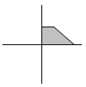

1. The figure below is missing a measurement for one line segment. What is the missing measurement?

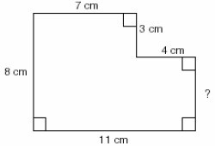

1. Each smaller square is made by joining the midpoints of the sides of the larger surrounding square. What fraction of the area of the square ABCD is shaded? Give your answer as a reduced fraction.

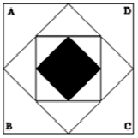

**BONUS PROBLEMS**

1. The vertices of a quadrilateral ABCD are A(3,1), B(1,-4), C(-6,0), and D(-3,7). If quadrilateral ABCD is translated 2 units up and 5 units to the right to create quadrilateral A’B’C’D’, what are the coordinates of vertex C’?

|  |  |
| --- | --- |
| 1. Find the measure of angle A: |  |
|  |

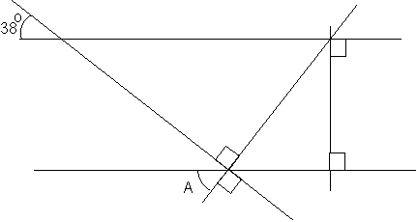

1. The two quadrilaterals below are similar. What is the value of x?



1. In this figure, all triangles shown are equilateral. What is the measure of angle B?   
   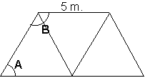

**Solutions**

*Note: There are many acceptable strategies to solving each problem. This sheet shows just one strategy.*

1. Along a straight line, the sum of all angles that make up the line is 180°.

Therefore, the *large* angle at point M is 180-40 = 140°.

In a rhombus, opposite angles are equal. Therefore, angle DAB = 140°.

**Answer: 140°**

1. Each rectangle has a short side which is ¼ the length of its long side.

Since the perimeter of each rectangle is 30 cm, the sum of the short side + long side = 15 cm.

Therefore the short side is 3 cm., and the long side is 12 cm.

Therefore each side of the square is 12 cm., and the perimeter is 48 cm.

**Answer: 48 cm.**

1. If you start at B, and move towards A, you ended up going 2 units left and 2 units down. Therefore, start at C and do the same thing … go 2 units left and 2 units down. You end up at (-4, 0).

**Answer: (-4, 0)**

1. If the perimeter is 24 inches, then the sum of one length + one width is half of that, or 12 inches.

Since the length is 3 inches, the width must be 9 inches.

9 in.

3 in.

**Answer: 9 inches**

1. Reflecting the trapezoid along the horizontal and vertical symmetry lines, and drawing it in all four quadrants, you get a six-sided figure, or a hexagon:

**Answer: hexagon**

1. Since everything is right angles, looking at just the vertical measurements shown, the missing side is 8 – 3 = 5

**Answer: 5 cm.**

1. If area of the square is 64, then one side of the square is 8.

If one side of the square is 8, then the perimeter is 32.

Perimeter of octagon is also 32.

So one side of the octagon is 32 ÷ 8 = 4

**Answer: 4 units**

1. Each smaller interior square rotated 45° has exactly half the area of its immediately encompassing larger square. One way to see this is to draw triangles as shown below. Each shaded triangle is exactly the same as its corresponding white triangle:

So, each time you draw a smaller square inside a bigger square, you are cutting the area in half.

So, $\frac{1}{2}$ × $\frac{1}{2}$ × $\frac{1}{2}$ = $\frac{1}{8}$

**Answer: $\frac{1}{8}$**

1. The original quadrilateral looks like this:

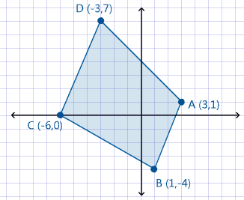

Translating this 2 units up and 5 units to the right gives us this:

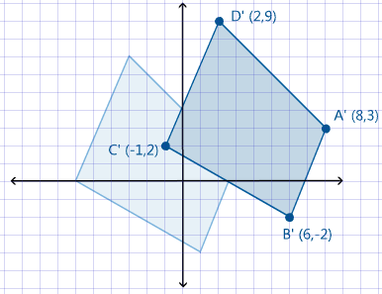

To calculate the new coordinates, we simply add 5 to each x-coordinate, and add 2 to each y-coordinate. So, the new coordinates of vertex C’ are (-1, 2).

**Answer: (-1, 2)**

1. There are several angles that are formed between the horizontal lines and the long diagonal line traveling from the upper-left to the lower-right of the figure. All of these angles must be the same, since the lines forming them are the same. Since the initially given angle is 38°, there are several other angles (marked below) that are also 38°, in particular the angle marked B.

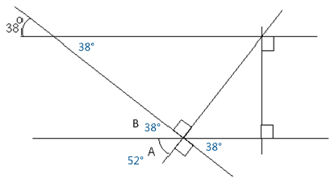

We also know that the sum of angles B and A form a right angle, or 90°, because the lines forming them are perpendicular lines. Therefore, angle A is 90 - 38 = 52°.

**Answer: 52°**

1. Similar quadrilaterals have sides that are the same ratio. From the diagram, we see that the longest side (16) in the large figure corresponds to the longest side (10) in the small figure. This is a ratio of 16:10, or 8:5. Therefore the ratio of the top sides must also be 8:5. So therefore the ratio of 10:x = 8:5. Therefore x = 5 ×10 ÷ 8 = 50 ÷ 8 = 6 ¼

**Answer: 6 ¼**

1. Equilateral triangles have three angles that are each 60°. The angle B in the diagram is the sum of two such angles. So angle B is 60 + 60 = 120°.

**Answer: 120°**